**Operating System Services**

An operating system provides an environment for the execution of programs. It provides certain services to programs and to the users of those programs. The specific services provided, of course, differ from one operating system to another, but we can identify common classes. These operating system services are provided for the convenience of the programmer, to make the programming task easier. Figure 1.11 shows one view of the various operating-system services and how they interrelate.

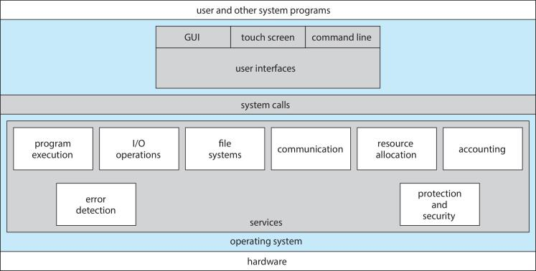

Figure 1.11 A view of operating system services.

One set of operating system services provides functions that are helpful to the user.

**• User interface**. Almost all operating systems have a user interface (UI). This interface can take several forms. One is a command-line interface (CLI), which uses text commands and a method for entering them (say, a keyboard for typing in commands in a specific format with specific options). Another is a batch interface, in which commands and directives to control those commands are entered into files, and those files are executed. Most commonly, a graphical user interface (GUI) is used. Here, the interface is a window system with a pointing device to direct I/O, choose from menus, and make selections and a keyboard to enter text. Some systems provide two or all three of these variations.

**• Program execution**. The system must be able to load a program into memory and to run that program. The program must be able to end its execution, either normally or abnormally (indicating error).

**• I/O operations**. A running program may require I/O, which may involve a file or an I/O device. For specific devices, special functions may be desired (such as recording to a CD or DVD drive or blanking a display screen). For efficiency and protection, users usually cannot control I/O devices directly. Therefore, the operating system must provide a means to do I/O.

**• File-system manipulation**. The file system is of particular interest. Obviously, programs need to read and write files and directories. They also need to create and delete them by name, search for a given file, and list file information. Finally, some operating systems include permissions management to allow or deny access to files or directories based on file ownership. Many operating systems provide a variety of file systems, sometimes to allow personal choice and sometimes to provide specific features or performance characteristics.

• **Communications**. There are many circumstances in which one process needs to exchange information with another process. Such communication may occur between processes that are executing on the same computer or between processes that are executing on different computer systems tied together by a computer network. Communications may be implemented via shared memory, in which two or more processes read and write to a shared section of memory, or message passing, in which packets of information in predefined formats are moved between processes by the operating system.

**• Error detection**. The operating system needs to be detecting and correcting errors constantly. Errors may occur in the CPU and memory hardware (such as a memory error or a power failure), in I/O devices (such as a parity error on disk, a connection failure on a network, or lack of paper in the printer), and in the user program (such as an arithmetic overflow, an attempt to access an illegal memory location, or a too-great use of CPU time). For each type of error, the operating system should take the appropriate action to ensure correct and consistent computing. Sometimes, it has no choice but to halt the system. At other times, it might terminate an error-causing process or return an error code to a process for the process to detect and possibly correct.

Another set of operating system functions exists not for helping the user but rather for ensuring the efficient operation of the system itself. Systems with multiple users can gain efficiency by sharing the computer resources among the users.

**• Resource allocation**. When there are multiple users or multiple jobs running at the same time, resources must be allocated to each of them. The operating system manages many different types of resources. Some (such as CPU cycles, main memory, and file storage) may have special allocation code, whereas others (such as I/O devices) may have much more general request and release code. For instance, in determining how best to use the CPU, operating systems have CPU-scheduling routines that take into account the speed of the CPU, the jobs that must be executed, the number of registers available, and other factors. There may also be routines to allocate printers, USB storage drives, and other peripheral devices.

**• Accounting**. We want to keep track of which users use how much and what kinds of computer resources. This record keeping may be used for accounting (so that users can be billed) or simply for accumulating usage statistics. Usage statistics may be a valuable tool for researchers who wish to reconfigure the system to improve computing services.

**• Protection and security**. The owners of information stored in a multiuser or networked computer system may want to control use of that information. When several separate processes execute concurrently, it should not be possible for one process to interfere with the others or with the operating system itself. Protection involves ensuring that all access to system resources is controlled. Security of the system from outsiders is also important. Such security starts with requiring each user to authenticate himself or herself to the system, usually by means of a password, to gain access to system resources. It extends to defending external I/O devices, including network adapters, from invalid access attempts and to recording all such connections for detection of break-ins. If a system is to be protected and secure, precautions must be instituted throughout it. A chain is only as strong as its weakest link.

**User Operating System Interface – CLI**

There are several ways for users to interface with the operating system. Here, we discuss two fundamental approaches. One provides a command-line interface, or command interpreter, that allows users to directly enter commands to be performed by the operating system. The other allows users to interface with the operating system via a graphical user interface, or GUI.

**Command Interpreters**

Some operating systems include the command interpreter in the kernel. Others, such as Windows and UNIX, treat the command interpreter as a special program that is running when a job is initiated or when a user first logs on (on interactive systems). On systems with multiple command interpreters to choose from, the interpreters are known as shells. For example, on UNIX and Linux systems, a user may choose among several different shells, including the Bourne shell, C shell, Bourne-Again shell, Korn shell, and others. Third-party shells and free user-written shells are also available. Most shells provide similar functionality, and a user’s choice of which shell to use is generally based on personal preference.

The main function of the command interpreter is to get and execute the next user-specified command. Many of the commands given at this level manipulate files: create, delete, list, print, copy, execute, and so on. The MS-DOS and UNIX shells operate in this way. These commands can be implemented in two general ways.

In one approach, the command interpreter itself contains the code to execute the command. For example, a command to delete a file may cause the command interpreter to jump to a section of its code that sets up the parameters and makes the appropriate system call. In this case, the number of commands that can be given determines the size of the command interpreter, since each command requires its own implementing code.

An alternative approach—used by UNIX, among other operating systems —implements most commands through system programs. In this case, the command interpreter does not understand the command in any way; it merely uses the command to identify a file to be loaded into memory and executed. Thus, the UNIX command to delete a file

rm file.txt

would search for a file called rm, load the file into memory, and execute it with the parameter file.txt. The function associated with the rm command would be defined completely by the code in the file rm. In this way, programmers can add new commands to the system easily by creating new files with the proper names. The command-interpreter program, which can be small, does not have to be changed for new commands to be added.

**Graphical User Interfaces**

A second strategy for interfacing with the operating system is through a userfriendly graphical user interface, or GUI. Here, rather than entering commands directly via a command-line interface, users employ a mouse-based windowand-menu system characterized by a desktop metaphor. The user moves the mouse to position its pointer on images, or icons, on the screen (the desktop) that represent programs, files, directories, and system functions. Depending on the mouse pointer’s location, clicking a button on the mouse can invoke a program, select a file or directory—known as a folder—or pull down a menu that contains commands.

Graphical user interfaces first appeared due in part to research taking place in the early 1970s at Xerox PARC research facility. The first GUI appeared on the Xerox Alto computer in 1973. However, graphical interfaces became more widespread with the advent of Apple Macintosh computers in the 1980s. The user interface for the Macintosh operating system (Mac OS) has undergone various changes over the years, the most significant being the adoption of the Aqua interface that appeared with Mac OS X. Microsoft’s first version of Windows—Version 1.0—was based on the addition of a GUI interface to the MS-DOS operating system. Later versions of Windows have made cosmetic changes in the appearance of the GUI along with several enhancements in its functionality.

**Touchscreen Interfaces**

Because a mouse is impractical for most mobile systems, smartphones and handheld tablet computers typically use a touchscreen interface. Here, users interact by making gestures on the touchscreen—for example, pressing and swiping fingers across the screen. Whereas earlier smartphones included a physical keyboard, most smartphones now simulate a keyboard on the touchscreen.

**System Calls**

System calls provide an interface to the services made available by an operating system. These calls are generally available as routines written in C and C++, although certain low-level tasks (for example, tasks where hardware must be accessed directly) may have to be written using assembly-language instructions.

Before we discuss how an operating system makes system calls available, let’s first use an example to illustrate how system calls are used: writing a simple program to read data from one file and copy them to another file. The first input that the program will need is the names of the two files: the input file and the output file. These names can be specified in many ways, depending on the operating-system design. One approach is for the program to ask the user for the names. In an interactive system, this approach will require a sequence of system calls, first to write a prompting message on the screen and then to read from the keyboard the characters that define the two files. On mouse-based and icon-based systems, a menu of file names is usually displayed in a window. The user can then use the mouse to select the source name, and a window can be opened for the destination name to be specified. This sequence requires many I/O system calls.

Once the two file names have been obtained, the program must open the input file and create the output file. Each of these operations requires another system call. Possible error conditions for each operation can require additional system calls. When the program tries to open the input file, for example, it may find that there is no file of that name or that the file is protected against access. In these cases, the program should print a message on the console (another sequence of system calls) and then terminate abnormally (another system call). If the input file exists, then we must create a new output file. We may find that there is already an output file with the same name. This situation may cause the program to abort (a system call), or we may delete the existing file (another system call) and create a new one (yet another system call). Another option, in an interactive system, is to ask the user (via a sequence of system calls to output the prompting message and to read the response from the terminal) whether to replace the existing file or to abort the program.

When both files are set up, we enter a loop that reads from the input file (a system call) and writes to the output file (another system call). Each read and write must return status information regarding various possible error conditions. On input, the program may find that the end of the file has been reached or that there was a hardware failure in the read (such as a parity error). The write operation may encounter various errors, depending on the output device (for example, no more disk space).

Finally, after the entire file is copied, the program may close both files (another system call), write a message to the console or window (more system calls), and finally terminate normally (the final system call). This system-call sequence is shown in Figure 1.12.

As you can see, even simple programs may make heavy use of the operating system. Frequently, systems execute thousands of system calls per second. Most programmers never see this level of detail, however. Typically, application developers design programs according to an application programming interface (API). The API specifies a set of functions that are available to an application programmer, including the parameters that are passed to each function and the return values the programmer can expect. Three of the most common APIs available to application programmers are the Windows API for Windows systems, the POSIX API for POSIX-based systems (which include virtually all versions of UNIX, Linux, and Mac OS X), and the Java API for programs that run on the Java virtual machine. A programmer accesses an API via a library of code provided by the operating system. In the case of UNIX and Linux for programs written in the C language, the library is called libc. Note that—unless specified—the system-call names used throughout this text are generic examples. Each operating system has its own name for each system call.

Behind the scenes, the functions that make up an API typically invoke the actual system calls on behalf of the application programmer. For example, the Windows function CreateProcess() (which unsurprisingly is used to create a new process) actually invokes the NTCreateProcess() system call in the Windows kernel.

Why would an application programmer prefer programming according to an API rather than invoking actual system calls? There are several reasons for doing so. One benefit concerns program portability. An application programmer designing a program using an API can expect her program to compile and run on any system that supports the same API (although, in reality, architectural differences often make this more difficult than it may appear). Furthermore, actual system calls can often be more detailed and difficult to work with than the API available to an application programmer. Nevertheless, there often exists a strong correlation between a function in the API and its associated system call within the kernel. In fact, many of the POSIX and Windows APIs are similar to the native system calls provided by the UNIX, Linux, and Windows operating systems.

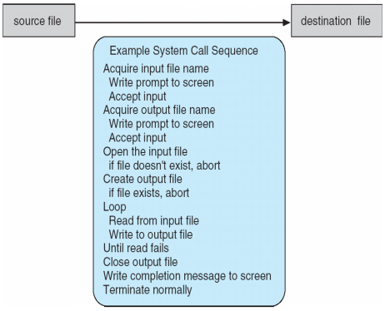

Figure 1.12 Example of how system calls are used.

For most programming languages, the run-time support system (a set of functions built into libraries included with a compiler) provides a systemcall interface that serves as the link to system calls made available by the operating system. The system-call interface intercepts function calls in the API and invokes the necessary system calls within the operating system. Typically, a number is associated with each system call, and the system-call interface maintains a table indexed according to these numbers. The system call interface then invokes the intended system call in the operating-system kernel and returns the status of the system call and any return values.

The caller need know nothing about how the system call is implemented or what it does during execution. Rather, the caller need only obey the API and understand what the operating system will do as a result of the execution of that system call. Thus, most of the details of the operating-system interface are hidden from the programmer by the API and are managed by the run-time support library. The relationship between an API, the system-call interface, and the operating system is shown in Figure 1.13, which illustrates how the operating system handles a user application invoking the open() system call.

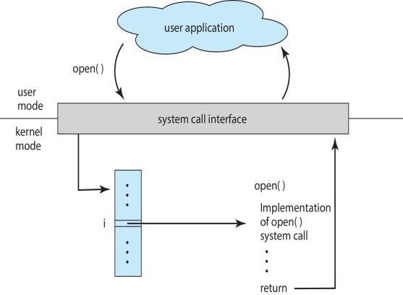

Figure 1.13 The handling of a user application invoking the open() system call.

System calls occur in different ways, depending on the computer in use. Often, more information is required than simply the identity of the desired system call. The exact type and amount of information vary according to the particular operating system and call. For example, to get input, we may need to specify the file or device to use as the source, as well as the address and length of the memory buffer into which the input should be read. Of course, the device or file and length may be implicit in the call.

Three general methods are used to pass parameters to the operating system. The simplest approach is to pass the parameters in registers. In some cases, however, there may be more parameters than registers. In these cases, the parameters are generally stored in a block, or table, in memory, and the address of the block is passed as a parameter in a register (Figure 1.14). This is the approach taken by Linux and Solaris. Parameters also can be placed, or pushed, onto the stack by the program and popped off the stack by the operating system. Some operating systems prefer the block or stack method because those approaches do not limit the number or length of parameters being passed.

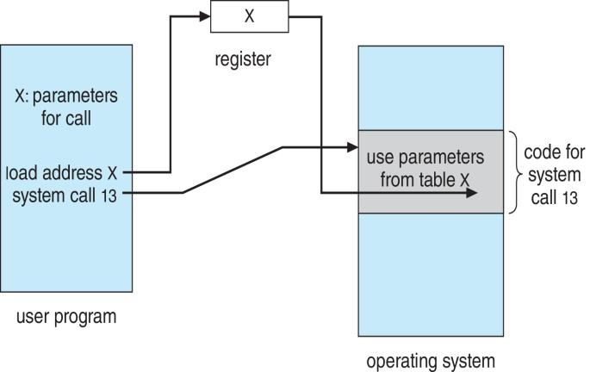

Figure 1.14 Passing of parameters as a table.

**Types of System Calls**

System calls can be grouped roughly into six major categories: process control, file manipulation, device manipulation, information maintenance, communications, and protection. Most of these system calls support, or are supported by, concepts and functions that are discussed in later chapters. Figure 2.8 summarizes the types of system calls normally provided by an operating system. As mentioned, in this text, we normally refer to the system calls by generic names. Throughout the text, however, we provide examples of the actual counterparts to the system calls for Windows, UNIX, and Linux systems.

**Process Control**

A running program needs to be able to halt its execution either normally (end()) or abnormally (abort()). If a system call is made to terminate the currently running program abnormally, or if the program runs into a problem and causes an error trap, a dump of memory is sometimes taken and an error message generated. The dump is written to disk and may be examined by a debugger—a system program designed to aid the programmer in finding and correcting errors, or bugs—to determine the cause of the problem. Under either normal or abnormal circumstances, the operating system must transfer control to the invoking command interpreter. The command interpreter then reads the next command. In an interactive system, the command interpreter simply continues with the next command; it is assumed that the user will issue an appropriate command to respond to any error. In a GUI system, a pop-up window might alert the user to the error and ask for guidance. In a batch system, the command interpreter usually terminates the entire job and continues with the next job. Some systems may allow for special recovery actions in case an error occurs. If the program discovers an error in its input and wants to terminate abnormally, it may also want to define an error level. More severe errors can be indicated by a higher-level error parameter. It is then possible to combine normal and abnormal termination by defining a normal termination as an error at level 0. The command interpreter or a following program can use this error level to determine the next action automatically.

• Process control

◦ end, abort

◦ load, execute

◦ create process, terminate process

◦ get process attributes, set process attributes

◦ wait for time

◦ wait event, signal event

◦ allocate and free memory

• File management

◦ create file, delete file

◦ open, close

◦ read, write, reposition

◦ get file attributes, set file attributes

• Device management

◦ request device, release device

◦ read, write, reposition

◦ get device attributes, set device attributes

◦ logically attach or detach devices

• Information maintenance

◦ get time or date, set time or date

◦ get system data, set system data

◦ get process, file, or device attributes

◦ set process, file, or device attributes

• Communications

◦ create, delete communication connection

◦ send, receive messages

◦ transfer status information

◦ attach or detach remote devices

A process or job executing one program may want to load() and execute() another program. This feature allows the command interpreter to execute a program as directed by, for example, a user command, the click of a mouse, or a batch command. An interesting question is where to return control when the loaded program terminates. This question is related to whether the existing program is lost, saved, or allowed to continue execution concurrently with the new program.

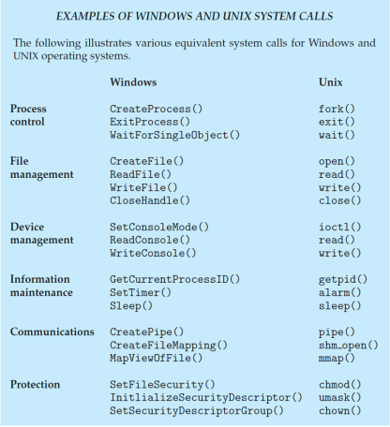

If control returns to the existing program when the new program terminates, we must save the memory image of the existing program; thus, we have effectively created a mechanism for one program to call another program. If both programs continue concurrently, we have created a new job or process to be multiprogrammed. Often, there is a system call specifically for this purpose (create process() or submit job()).

If we create a new job or process, or perhaps even a set of jobs or processes, we should be able to control its execution. This control requires the ability to determine and reset the attributes of a job or process, including the job’s priority, its maximum allowable execution time, and so on (get process attributes() and set process attributes()). We may also want to terminate a job or process that we created (terminate process()) if we find that it is incorrect or is no longer needed.

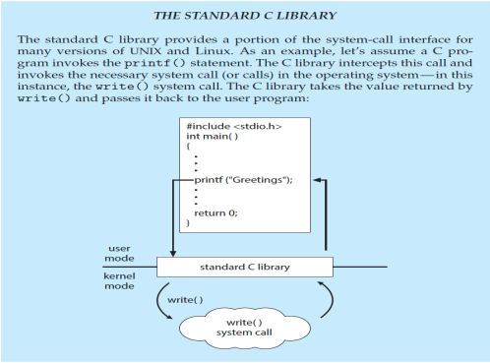

Having created new jobs or processes, we may need to wait for them to finish their execution. We may want to wait for a certain amount of time to pass (wait time()). More probably, we will want to wait for a specific event to occur (wait event()). The jobs or processes should then signal when that event has occurred (signal event()).

Quite often, two or more processes may share data. To ensure the integrity of the data being shared, operating systems often provide system calls allowing a process to lock shared data. Then, no other process can access the data until the lock is released. Typically, such system calls include acquire lock() and release lock(). System calls of these types, dealing with the coordination of concurrent processes.

There are so many facets of and variations in process and job control that we next use two examples—one involving a single-tasking system and the other a multitasking system—to clarify these concepts. The MS-DOS operating system is an example of a single-tasking system. It has a command interpreter that is invoked when the computer is started (Figure 1.15(a)). Because MS-DOS is single-tasking, it uses a simple method to run a program and does not create a new process. It loads the program into memory, writing over most of itself to give the program as much memory as possible (Figure 1.15(b)). Next, it sets the instruction pointer to the first instruction of the program. The program then runs, and either an error causes a trap, or the program executes a system call to terminate. In either case, the error code is saved in the system memory for later use. Following this action, the small portion of the command interpreter that was not overwritten resumes execution. Its first task is to reload the rest of the command interpreter from disk. Then the command interpreter makes the previous error code available to the user or to the next program.

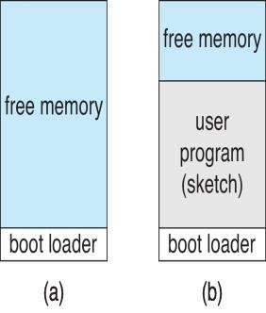

Figure 1.15 MS-DOS execution. (a) At system startup. (b) Running a program.

previous error code available to the user or to the next program. FreeBSD (derived from Berkeley UNIX) is an example of a multitasking system. When a user logs on to the system, the shell of the user’s choice is run. This shell is similar to the MS-DOS shell in that it accepts commands and executes programs that the user requests. However, since FreeBSD is a multitasking system, the command interpreter may continue running while another program is executed (Figure 2.10). To start a new process, the shell executes a fork() system call. Then, the selected program is loaded into memory via an exec() system call, and the program is executed. Depending on the way the command was issued, the shell then either waits for the process to finish or runs the process “in the background.” In the latter case, the shell immediately requests another command. When a process is running in the background, it cannot receive input directly from the keyboard, because the shell is using this resource. I/O is therefore done through files or through a GUI interface. Meanwhile, the user is free to ask the shell to run other programs, to monitor the progress of the running process, to change that program’s priority, and so on. When the process is done, it executes an exit() system call to terminate, returning to the invoking process a status code of 0 or a nonzero error code. This status or error code is then available to the shell or other programs. Processes are discussed in Chapter 3 with a program example using the fork() and exec() system calls.

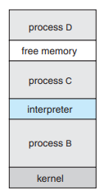

Figure 1.16 FreeBSD running multiple programs.

**System Programs**

Another aspect of a modern system is its collection of system programs. Recall Figure 1.1, which depicted the logical computer hierarchy. At the lowest level is hardware. Next is the operating system, then the system programs, and finally the application programs. System programs, also known as system utilities, provide a convenient environment for program development and execution. Some of them are simply user interfaces to system calls. Others are considerably more complex. They can be divided into these categories:

**• File management**. These programs create, delete, copy, rename, print, dump, list, and generally manipulate files and directories.

**• Status information**. Some programs simply ask the system for the date, time, amount of available memory or disk space, number of users, or similar status information. Others are more complex, providing detailed performance, logging, and debugging information. Typically, these programs format and print the output to the terminal or other output devices or files or display it in a window of the GUI. Some systems also support a registry, which is used to store and retrieve configuration information.

**• File modification**. Several text editors may be available to create and modify the content of files stored on disk or other storage devices. There may also be special commands to search contents of files or perform transformations of the text.

**• Programming-language support**. Compilers, assemblers, debuggers, and interpreters for common programming languages (such as C, C++, Java, and PERL) are often provided with the operating system or available as a separate download.

**• Program loading and execution**. Once a program is assembled or compiled, it must be loaded into memory to be executed. The system may provide absolute loaders, relocatable loaders, linkage editors, and overlay loaders. Debugging systems for either higher-level languages or machine language are needed as well.

**• Communications**. These programs provide the mechanism for creating virtual connections among processes, users, and computer systems. They allow users to send messages to one another’s screens, to browse Web pages, to send e-mail messages, to log in remotely, or to transfer files from one machine to another.

**• Background services**. All general-purpose systems have methods for launching certain system-program processes at boot time. Some of these processes terminate after completing their tasks, while others continue to run until the system is halted. Constantly running system-program processes are known as services, subsystems, or daemons. One example is the network daemon discussed in Section 2.4.5. In that example, a system needed a service to listen for network connections in order to connect those requests to the correct processes. Other examples include process schedulers that start processes according to a specified schedule, system error monitoring services, and print servers. Typical systems have dozens of daemons. In addition, operating systems that run important activities in user context rather than in kernel context may use daemons to run these activities.

Along with system programs, most operating systems are supplied with programs that are useful in solving common problems or performing common operations. Such application programs include Web browsers, word processors and text formatters, spreadsheets, database systems, compilers, plotting and statistical-analysis packages, and games.

The view of the operating system seen by most users is defined by the application and system programs, rather than by the actual system calls. Consider a user’s PC. When a user’s computer is running the Mac OS X operating system, the user might see the GUI, featuring a mouse-and-windows interface. Alternatively, or even in one of the windows, the user might have a command-line UNIX shell. Both use the same set of system calls, but the system calls look different and act in different ways. Further confusing the user view, consider the user dual-booting from Mac OS X into Windows. Now the same user on the same hardware has two entirely different interfaces and two sets of applications using the same physical resources. On the same hardware, then, a user can be exposed to multiple user interfaces sequentially or concurrently.

**Linkers and Loaders**

**Linkers**

A linker is a program that allows a user to link library programs or separate modules of code into their own programs. It is used to combine different modules of object code into one single executable code program. This may involve combining a program with library programs, or involve recombining blocks of object code from the same program, or a mixture of both.

* A program may call library modules.
* Library modules will use data stored in ‘relative addresses’. See the section below on loaders for more about relative addressing.
* The program itself is compiled.
* The library modules are compiled.
* The linker program is run.
* The compiled library modules are linked to (connected to) the compiled program.
* Base addresses used in the library modules are adjusted so that the calls in them to data work from within the main program.
* One executable program is produced.

Linkers are also used when a user has to compile a big program in sections, perhaps because there is a shortage of RAM. The user's program is split up into sections and held on backing storage. Each section is then brought into RAM, one section at a time, from backing storage and compiled into object code. Each block of object code is then saved back to the backing storage. When the whole program is compiled, the compiler can be removed from RAM and all of the blocks of object code can then be brought into RAM because there is enough space without the compiler program. The linker program is used to recombine the blocks of object code in RAM to get a working full program.

**Loaders**

A loader is a piece of software that chooses exactly where to put object code in RAM, ready for it to be run. It also adjusts the memory references in programs. These pieces of software are explained in more detail below.

The job of a piece of software known as a loader is to take the object code generated by compilation and to find a 'good' place for it in RAM, where it can then be executed. Imagine that a software house has written a program to sell to the public. They wrote the source code, compiled it so that they then had some object code, and then copied the object code onto a CD, ready to sell. They wouldn't distribute the source code because they would want to keep the actual program code secret from competitors - it is practically impossible to turn object code back into source code. Besides, your customers may not have the necessary compilers on their machines to convert the source code into object code. In addition, it would be a little inconvenient if your customers had to compile every program they wanted to use before they actually used it!

If you bought the CD and wanted to run the program, you might double click on the .exe file. The loader would then copy the object code from the CD into your RAM and run it from there. But where in RAM would the loader put it? You have other applications running in RAM, for example, the operating system and a virus checker. You may also be multi-tasking, with various programs and data in RAM. If the loader is not careful, it will load a program in a place in RAM that interferes with other programs. Your loader program, then, must decide where to put the object code in RAM so that it doesn't interfere with other programs and data. This is the first main job of the loader program.

The second main job involves adjusting references that are used within a program. Programs can be written by programmers using either ‘absolute addressing’ or ‘relative addressing’. Relative addressing is more common because then the loader can put the program anywhere in RAM - absolute addressing isn't flexible.

**Operating System Design and Implementation**

In this section, we discuss problems we face in designing and implementing an operating system. There are, of course, no complete solutions to such problems, but there are approaches that have proved successful.

**Design Goals**

The first problem in designing a system is to define goals and specifications. At the highest level, the design of the system will be affected by the choice of hardware and the type of system: batch, time sharing, single user, multiuser, distributed, real time, or general purpose.

Beyond this highest design level, the requirements may be much harder to specify. The requirements can, however, be divided into two basic groups: user goals and system goals.

Users want certain obvious properties in a system. The system should be convenient to use, easy to learn and to use, reliable, safe, and fast. Of course, these specifications are not particularly useful in the system design, since there is no general agreement on how to achieve them.

A similar set of requirements can be defined by those people who must design, create, maintain, and operate the system. The system should be easy to design, implement, and maintain; and it should be flexible, reliable, error free, and efficient. Again, these requirements are vague and may be interpreted in various ways.

There is, in short, no unique solution to the problem of defining the requirements for an operating system. The wide range of systems in existence shows that different requirements can result in a large variety of solutions for different environments. For example, the requirements for VxWorks, a real-time operating system for embedded systems, must have been substantially different from those for MVS, a large multiuser, multiaccess operating system for IBM mainframes.

Specifying and designing an operating system is a highly creative task. Although no textbook can tell you how to do it, general principles have been developed in the field of software engineering, and we turn now to a discussion of some of these principles.

**Mechanisms and Policies**

One important principle is the separation of policy from mechanism. Mechanisms determine how to do something; policies determine what will be done. For example, the timer construct is a mechanism for ensuring CPU protection, but deciding how long the timer is to be set for a particular user is a policy decision.

The separation of policy and mechanism is important for flexibility. Policies are likely to change across places or over time. In the worst case, each change in policy would require a change in the underlying mechanism. A general mechanism insensitive to changes in policy would be more desirable. A change in policy would then require redefinition of only certain parameters of the system. For instance, consider a mechanism for giving priority to certain types of programs over others. If the mechanism is properly separated from policy, it can be used either to support a policy decision that I/O-intensive programs should have priority over CPU-intensive ones or to support the opposite policy.

Microkernel-based operating systems take the separation of mechanism and policy to one extreme by implementing a basic set of primitive building blocks. These blocks are almost policy free, allowing more advanced mechanisms and policies to be added via user-created kernel modules or user programs themselves. As an example, consider the history of UNIX. At first, it had a time-sharing scheduler. In the latest version of Solaris, scheduling is controlled by loadable tables. Depending on the table currently loaded, the system can be time sharing, batch processing, real time, fair share, or any combination. Making the scheduling mechanism general purpose allows vast policy changes to be made with a single load-new-table command. At the other extreme is a system such as Windows, in which both mechanism and policy are encoded in the system to enforce a global look and feel. All applications have similar interfaces, because the interface itself is built into the kernel and system libraries. The Mac OS X operating system has similar functionality.

Policy decisions are important for all resource allocation. Whenever it is necessary to decide whether or not to allocate a resource, a policy decision must be made. Whenever the question is how rather than what, it is a mechanism that must be determined.

**Implementation**

Once an operating system is designed, it must be implemented. Because operating systems are collections of many programs, written by many people over a long period of time, it is difficult to make general statements about how they are implemented.

Early operating systems were written in assembly language. Now, although some operating systems are still written in assembly language, most are written in a higher-level language such as C or an even higher-level language such as C++. Actually, an operating system can be written in more than one language. The lowest levels of the kernel might be assembly language. Higher-level routines might be in C, and system programs might be in C or C++, in interpreted scripting languages like PERL or Python, or in shell scripts. In fact, a given Linux distribution probably includes programs written in all of those languages.

The first system that was not written in assembly language was probably the Master Control Program (MCP) for Burroughs computers. MCP was written in a variant of ALGOL. MULTICS, developed at MIT, was written mainly in the system programming language PL/1. The Linux and Windows operating system kernels are written mostly in C, although there are some small sections of assembly code for device drivers and for saving and restoring the state of registers.

The advantages of using a higher-level language, or at least a systemsimplementation language, for implementing operating systems are the same as those gained when the language is used for application programs: the code can be written faster, is more compact, and is easier to understand and debug. In addition, improvements in compiler technology will improve the generated code for the entire operating system by simple recompilation. Finally, an operating system is far easier to port—to move to some other hardware— if it is written in a higher-level language. For example, MS-DOS was written in Intel 8088 assembly language. Consequently, it runs natively only on the Intel X86 family of CPUs. (Note that although MS-DOS runs natively only on Intel X86, emulators of the X86 instruction set allow the operating system to run on other CPUs—but more slowly, and with higher resource use. As we mentioned in Chapter 1, emulators are programs that duplicate the functionality of one system on another system.) The Linux operating system, in contrast, is written mostly in C and is available natively on a number of different CPUs, including Intel X86, Oracle SPARC, and IBMPowerPC.

The only possible disadvantages of implementing an operating system in a higher-level language are reduced speed and increased storage requirements. This, however, is no longer a major issue in today’s systems. Although an expert assembly-language programmer can produce efficient small routines, for large programs a modern compiler can perform complex analysis and apply sophisticated optimizations that produce excellent code. Modern processors have deep pipelining and multiple functional units that can handle the details of complex dependencies much more easily than can the human mind.

As is true in other systems, major performance improvements in operating systems are more likely to be the result of better data structures and algorithms than of excellent assembly-language code. In addition, although operating systems are large, only a small amount of the code is critical to high performance; the interrupt handler, I/O manager, memory manager, and CPU scheduler are probably the most critical routines. After the system is written and is working correctly, bottleneck routines can be identified and can be replaced with assembly-language equivalents.

**Operating System Structure**

A system as large and complex as a modern operating system must be engineered carefully if it is to function properly and be modified easily. A common approach is to partition the task into small components, or modules, rather than have one monolithic system. Each of these modules should be a well-defined portion of the system, with carefully defined inputs, outputs, and functions. We have already discussed briefly the common components of operating systems. In this section, we discuss how these components are interconnected and melded into a kernel.

**Simple Structure**

Many operating systems do not have well-defined structures. Frequently, such systems started as small, simple, and limited systems and then grew beyond their original scope. MS-DOS is an example of such a system. It was originally designed and implemented by a few people who had no idea that it would become so popular. It was written to provide the most functionality in the least space, so it was not carefully divided into modules. Figure 1.16 shows its structure.

In MS-DOS, the interfaces and levels of functionality are not well separated. For instance, application programs are able to access the basic I/O routines to write directly to the display and disk drives. Such freedom leaves MS-DOS vulnerable to errant (or malicious) programs, causing entire system crashes when user programs fail. Of course, MS-DOS was also limited by the hardware of its era. Because the Intel 8088 for which it was written provides no dual mode and no hardware protection, the designers of MS-DOS had no choice but to leave the base hardware accessible.

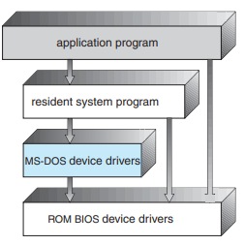

Figure 1.16 MS-DOS layer structure.

Another example of limited structuring is the original UNIX operating system. Like MS-DOS, UNIX initially was limited by hardware functionality. It consists of two separable parts: the kernel and the system programs. The kernel is further separated into a series of interfaces and device drivers, which have been added and expanded over the years as UNIX has evolved. We can view the traditional UNIX operating system as being layered to some extent, as shown in Figure 1.17. Everything below the system-call interface and above the physical hardware is the kernel. The kernel provides the file system, CPU scheduling, memory management, and other operating-system functions through system calls. Taken in sum, that is an enormous amount of functionality to be combined into one level. This monolithic structure was difficult to implement and maintain. It had a distinct performance advantage, however: there is very little overhead in the system call interface or in communication within the kernel. We still see evidence of this simple, monolithic structure in the UNIX, Linux, and Windows operating systems.

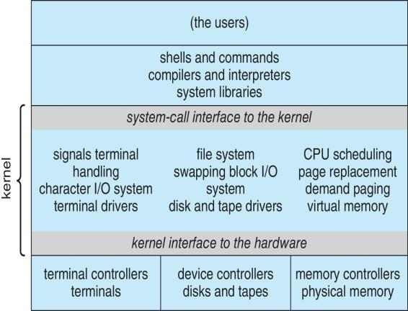

Figure 1.17 Traditional UNIX system structure.

**Layered Approach**

With proper hardware support, operating systems can be broken into pieces that are smaller and more appropriate than those allowed by the original MS-DOS and UNIX systems. The operating system can then retain much greater control over the computer and over the applications that make use of that computer. Implementers have more freedom in changing the inner workings of the system and in creating modular operating systems. Under a topdown approach, the overall functionality and features are determined and are separated into components. Information hiding is also important, because it leaves programmers free to implement the low-level routines as they see fit, provided that the external interface of the routine stays unchanged and that the routine itself performs the advertised task.

A system can be made modular in many ways. One method is the layered approach, in which the operating system is broken into a number of layers (levels). The bottom layer (layer 0) is the hardware; the highest (layer N) is the user interface. This layering structure is depicted in Figure 1.18.

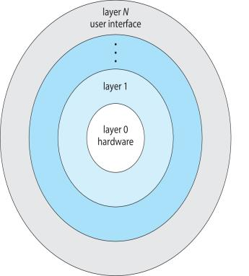

Figure 1.18 A layered operating system.

An operating-system layer is an implementation of an abstract object made up of data and the operations that can manipulate those data. A typical operating-system layer—say, layer M—consists of data structures and a set of routines that can be invoked by higher-level layers. Layer M, in turn, can invoke operations on lower-level layers.

The main advantage of the layered approach is simplicity of construction and debugging. The layers are selected so that each uses functions (operations) and services of only lower-level layers. This approach simplifies debugging and system verification. The first layer can be debugged without any concern for the rest of the system, because, by definition, it uses only the basic hardware (which is assumed correct) to implement its functions. Once the first layer is debugged, its correct functioning can be assumed while the second layer is debugged, and so on. If an error is found during the debugging of a particular layer, the error must be on that layer, because the layers below it are already debugged. Thus, the design and implementation of the system are simplified.

Each layer is implemented only with operations provided by lower-level layers. A layer does not need to know how these operations are implemented; it needs to know only what these operations do. Hence, each layer hides the existence of certain data structures, operations, and hardware from higher-level layers.

The major difficulty with the layered approach involves appropriately defining the various layers. Because a layer can use only lower-level layers, careful planning is necessary. For example, the device driver for the backing store (disk space used by virtual-memory algorithms) must be at a lower level than the memory-management routines, because memory management requires the ability to use the backing store.

Other requirements may not be so obvious. The backing-store driver would normally be above the CPU scheduler, because the driver may need to wait for I/O and the CPU can be rescheduled during this time. However, on a large system, the CPU scheduler may have more information about all the active processes than can fit in memory. Therefore, this information may need to be swapped in and out of memory, requiring the backing-store driver routine to be below the CPU scheduler.

A final problem with layered implementations is that they tend to be less efficient than other types. For instance, when a user program executes an I/O operation, it executes a system call that is trapped to the I/O layer, which calls the memory-management layer, which in turn calls the CPU-scheduling layer, which is then passed to the hardware. At each layer, the parameters may be modified, data may need to be passed, and so on. Each layer adds overhead to the system call. The net result is a system call that takes longer than does one on a nonlayered system.

These limitations have caused a small backlash against layering in recent years. Fewer layers with more functionality are being designed, providing most of the advantages of modularized code while avoiding the problems of layer definition and interaction.

**Microkernels**

We have already seen that as UNIX expanded, the kernel became large and difficult to manage. In the mid-1980s, researchers at Carnegie Mellon University developed an operating system called Mach that modularized the kernel using the microkernel approach. This method structures the operating system by removing all nonessential components from the kernel and implementing them as system and user-level programs. The result is a smaller kernel. There is little consensus regarding which services should remain in the kernel and which should be implemented in user space. Typically, however, microkernels provide minimal process and memory management, in addition to a communication facility. Figure 1.19 illustrates the architecture of a typical microkernel.

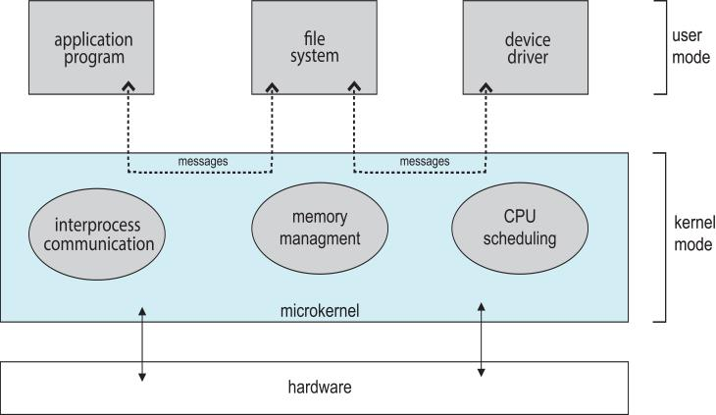

Figure 1.19 Architecture of a typical microkernel.

The main function of the microkernel is to provide communication between the client program and the various services that are also running in user space. Communication is provided through message passing. For example, if the client program wishes to access a file, it must interact with the file server. The client program and service never interact directly. Rather, they communicate indirectly by exchanging messages with the microkernel.

One benefit of the microkernel approach is that it makes extending the operating system easier. All new services are added to user space and consequently do not require modification of the kernel. When the kernel does have to be modified, the changes tend to be fewer, because the microkernel is a smaller kernel. The resulting operating system is easier to port from one hardware design to another. The microkernel also provides more security and reliability, since most services are running as user—rather than kernel— processes. If a service fails, the rest of the operating system remains untouched.

Some contemporary operating systems have used the microkernel approach. Tru64 UNIX (formerly Digital UNIX) provides a UNIX interface to the user, but it is implemented with a Mach kernel. The Mach kernel maps UNIX system calls into messages to the appropriate user-level services. The Mac OS X kernel (also known as Darwin) is also partly based on the Mach microkernel.

Another example is QNX, a real-time operating system for embedded systems. The QNX Neutrino microkernel provides services for message passing and process scheduling. It also handles low-level network communication and hardware interrupts. All other services in QNX are provided by standard processes that run outside the kernel in user mode.

Unfortunately, the performance of microkernels can suffer due to increased system-function overhead. Consider the history of Windows NT. The first release had a layered microkernel organization. This version’s performance was low compared with that of Windows 95. Windows NT 4.0 partially corrected the performance problem by moving layers from user space to kernel space and integrating them more closely. By the time Windows XP was designed, Windows architecture had become more monolithic than microkernel.

**Modules**

Perhaps the best current methodology for operating-system design involves using loadable kernel modules. Here, the kernel has a set of core components and links in additional services via modules, either at boot time or during run time. This type of design is common in modern implementations of UNIX, such as Solaris, Linux, and Mac OS X, as well as Windows.

The idea of the design is for the kernel to provide core services while other services are implemented dynamically, as the kernel is running. Linking services dynamically is preferable to adding new features directly to the kernel, which would require recompiling the kernel every time a change was made. Thus, for example, we might build CPU scheduling and memory management algorithms directly into the kernel and then add support for different file systems by way of loadable modules.

The overall result resembles a layered system in that each kernel section has defined, protected interfaces; but it is more flexible than a layered system, because any module can call any other module. The approach is also similar to the microkernel approach in that the primary module has only core functions and knowledge of how to load and communicate with other modules; but it is more efficient, because modules do not need to invoke message passing in order to communicate.

**Hybrid Systems**

In practice, very few operating systems adopt a single, strictly defined structure. Instead, they combine different structures, resulting in hybrid systems that address performance, security, and usability issues. For example, both Linux and Solaris are monolithic, because having the operating system in a single address space provides very efficient performance. However, they are also modular, so that new functionality can be dynamically added to the kernel. Windows is largely monolithic as well (again primarily for performance reasons), but it retains some behavior typical of microkernel systems, including providing support for separate subsystems (known as operating-system personalities) that run as user-mode processes. Windows systems also provide support for dynamically loadable kernel modules.